Systematic Theology: Soteriology
Week 6: Progressive Sanctification

Introduction to the series
- When you hear the word soteriology, what does mean to you?
- Some think of high theology, stuffy rooms, and old men arguing over large oak tables.
- Others think…I have no idea what that word means…and I probably don’t care even if I did.
- Hopefully you land somewhere between these two descriptions.
- Simply put, soteriology is the study of salvation or the study of the doctrine of salvation.
- In other words, it is the study of what one group of people believe about salvation. That group can be anything from a church to a political party. For our purposes, we are going to study what the Bible says.
- It is important to have a full and broad understanding of what the Bible says about our salvation so that we know that we are saved and so that we know what comes with our salvation.
- There are many different ideas and teachings about salvation, and it is our responsibility to make sure that we know what God has ordained and expects from His creation.
- Here is schedule for the upcoming lessons:
  - 09/08: Introduction
  - 09/15: What is the atonement, both declarative and practical?
  - 09/22: What does effectual calling, faith and repentance mean?
  - 09/29: Missionary Share: Tim George from Mozambique
  - 10/06: What is justification or what does it mean to be justified?
  - 10/13: What does it mean to be adopted by God?
  - 10/20: What is progressive sanctification and how does it operate in my daily Christian life?
  - 10/27: Missionary Share: Jeff Street from Canada
  - 11/03: What does the perseverance of the saints mean for me today and for eternity?

UNDERSTANDING Positional and progressive sanctification
- Before digging into this topic, we should take a moment to define our terms to understand what it is that we’re talking about.
- Some of the greatest confusion can come from not understanding the distinctions between the different ways that God’s word uses the term ‘sanctification’.
  - This term that, generally, means ‘separation’ or ‘set apart from sin unto God’.
  - The use of the term “sanctification” in Scripture can refer to both God’s work in salvation and the believer’s progressive sanctification.
- With that, it would be helpful to bring some clarity into how the term “sanctification” is used biblically, so that we can better understand how, and to what extent, believers are set apart from sin unto God:
  - Positional (Past/Objective/Initial) Sanctification
    - The work of God in saving believers results in their sanctification, in that they are set aside as God’s own possession and declared holy by faith in Christ’s justifying work:
      - It is a past and permanent work of God
        - This happens instantaneously at the time of salvation (1 Cor 6:11)
        - It is unconditional and irrevocable (Heb 10:10-14)
        - It is monergistic, meaning a one-sided work of God alone (1 Cor 1:2)
      - It is a status conferred to the believer
        - This is an objective reality for every believer, where they are declared holy by Christ’s atoning work (i.e. justification)
        - Believers are called saints [lit. “sanctified ones”] (Eph 1:1; Phil 1:1; Col 1:1)
      - It results in separation from sin in the form of freedom from bondage to sin
        - Though sin is still present, it’s enslaving power over a believer is broken, and they now have the capacity to reject sin, killing it, and not allowing it to reign in them (Rom 6:6, 11-12, 14)
      - It results in the believer being set apart to God
        - Paired with the breaking of the bondage of sin is a transferring from the kingdom of darkness to the kingdom of God’s Son (Col 1:13)
        - Believers are no longer slaves to sin, but rather, are now slaves to righteousness. (Rom 6:18)

  - Progressive (Current) Sanctification
    - When speaking of sanctification, this is overwhelmingly the most common meaning.
    - “Sanctification is the continuing work of God in the life of the believer, making him or her actually holy. By ‘holy’ here is meant ‘bearing an actual likeness to God’. Sanctification is a process by which one’s moral condition is brought into conformity with one’s legal status before God. It is a continuation of what was begun in regeneration, when a newness of life was conferred upon and instilled with the believer.”
      - This is the current and ongoing work of God and man (synergistic)
        - Philippians 2:12-13 - So then, my beloved, just as you have always obeyed, not as in my presence only, but now much more in my absence, work out your salvation with fear and trembling; for it is God who is at work in you, both to will and to work for His good pleasure.
        - This does not happen in a moment, but rather, throughout the whole life of the believer, and it involves the believer coming under and conforming to the word of God through the empowering work of the Holy Spirit.
      - This is not a status, but a pursuit of further separation from sin and conformity into Christlikeness
        - Philippians 3:12 - Not that I have already obtained it or have already become perfect, but I press on so that I may lay hold of that for which also I was laid hold of by Christ Jesus.
        - Because this work of dying to sin and pursuing Christlikeness is ongoing, it is not a declared state, but a command. We are to be holy as our heavenly Father is holy (1 Pet 1:15-16).
        - Believers are at different stages of this process, and it will not be completed until we are with Christ in glory (Phil 3:20-21; 1 John 3:2)

Justification Progressive Sanctification
Legal Standing | Internal Condition
Once for all time | Continuous throughout life
Entirely God’s Work | We cooperate
Perfect in this life | Not perfect in this life
The same in all Christians | Greater in some than in others
(Chart from Wayne Grudem, Systematic Theology, 747).

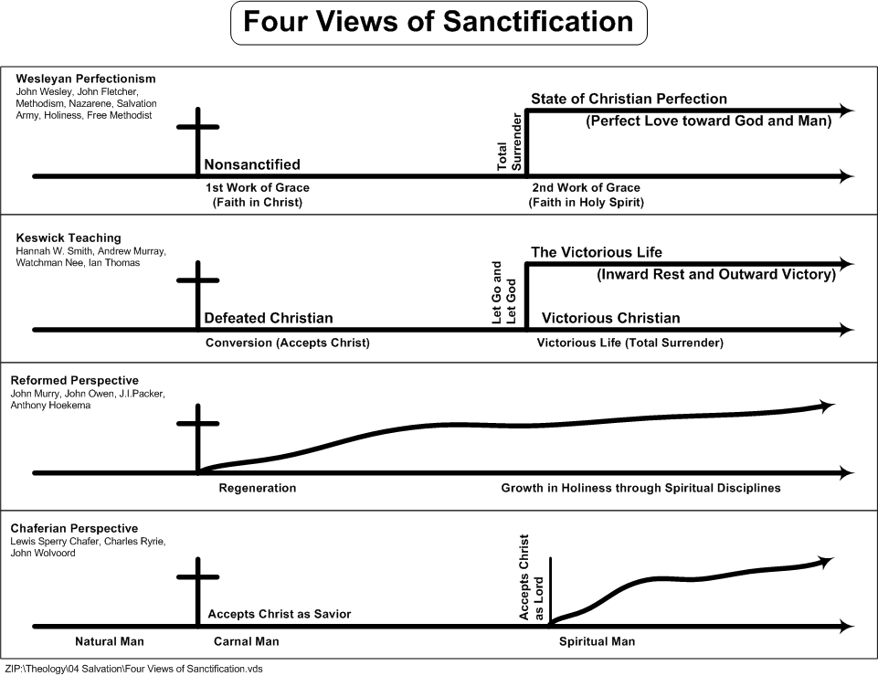

WHY STUDY SANCTIFICATION IN THIS CLASS?
- Having observed some of the wondrous truths of our salvation and our new standing before God, we want to take some time, now, to unpack the process of our progressive sanctification.
  - This is a period of maturing and growth of the believer into conformity with their Savior.
- However, before we seek to understand what sanctification is, the question you may be asking yourself is, “Why study sanctification in a class regarding the study of salvation?”.
- There are a few reasons to consider this:

  - Sanctification is the outworking of salvation in the life of a believer.
    - Colossians 1:21-23 - And although you were formerly alienated and hostile in mind, engaged in evil deeds, yet He has now reconciled you in His fleshly body through death, in order to present you before Him holy and blameless and beyond reproach— if indeed you continue in the faith firmly established and steadfast, and not moved away from the hope of the gospel that you have heard, which was proclaimed in all creation under heaven, and of which I, Paul, was made a minister.
      - Now, while the terms ‘salvation’ and ‘sanctification’ aren’t stated explicitly in this passage, it is clear that Paul’s intention is to convey that those who have been reconciled to God through Christ will continue on in the faith – established and steadfast.
      - Those who have experienced the grace of God will continue to grow through sanctification.
    - Philippians 2:12-13 - So then, my beloved, just as you have always obeyed, not as in my presence only, but now much more in my absence, work out your salvation with fear and trembling; for it is God who is at work in you, both to will and to work for His good pleasure.
      - This is one of the central passages on the topic of sanctification.
      - Notice Paul’s language, “work out your salvation…”. What does he mean here?
        - This is not referring to salvation by works
        - Rather, this is salvation that is evidenced by works. The ‘working out’ is speaking of the outworking of God’s grace in the life of the believer.

  - Our sanctification is grounded upon the work of salvation.
    - In viewing sanctification as an outworking of salvation, it reminds us that there can be no understanding or pursuit of sanctification without the foundation of our salvation in Christ.
    - Think through the “formula” of New Testament epistles…
      - Indicative Imperative
      - These are the truths of salvation; THEREFORE, this is how you ought to live…
    - We cannot hope to grow in Christ if we’re not IN CHRIST!
      - Any attempts at a change in living without a heart change is simply behavior modification (simply picking off the fruit and expecting something different to grow)
    - 1 Corinthians 6:9-11 - Or do you not know that the unrighteous will not inherit the kingdom of God? Do not be deceived; neither fornicators, nor idolaters, nor adulterers, nor effeminate, nor homosexuals, nor thieves, nor the covetous, nor drunkards, nor revilers, nor swindlers, will inherit the kingdom of God. Such were some of you; but you were washed, but you were sanctified, but you were justified in the name of the Lord Jesus Christ and in the Spirit of our God.

  - Understanding the connection between salvation and sanctification keeps believers tethered to the gospel.
    - This is really one of the greatest implications that can be derived from a right understanding of salvation and sanctification: believers need the gospel daily!
    - “Once we trust in Christ, so the thinking goes, the gospel doesn’t apply to us anymore, except to share it with others who are still unbelievers. However, though we truly are saints in the sense of being separated unto God, all of us are still practicing sinners.”
    - Are you tempted toward sin?
      - Remember that you were bought with a price and that your body is not your own (1 Cor 6); Don’t find pleasure in the things that Christ died for.
    - Are you discouraged?
      - Remember that you have been born again to a living hope through the resurrection of Jesus Christ and that you have a heavenly inheritance and are protected by the power of God Himself (1 Pet 1:3-5)
    - Are you tempted to doubt the character of God?
      - Remember that we are loved by God and have been called His children, and we will one day be like Him completely when we see Him face to face (1 John 3:1-2)

the “dependent responsibility” of Progressive sanctification
- Thinking now of how sanctification operates in the life of a believer, it is crucial to understand the nature of our sanctification.
  - Who is responsible for a believers sanctification? Is it God’s work in us to make us more like Christ, or is it man’s responsibility to pursue Christlikeness?

  - Scripture is clear that both are true!

- “There is a fundamental principle of the Christian life that I call the principle of dependent responsibility; that is, we are responsible before God to obey His Word, to put to death the sins in our lives, both the so-called acceptable sins and the obviously not acceptable ones. At the same time, we do not have the ability within ourselves to carry out that responsibility. We are in fact totally dependent upon the enabling power of the Holy Spirit. In this sense, we are both responsible and dependent.”
  - While our salvation is solely a work of God in us through Christ, our progressive sanctification is a synergistic work, meaning that both parties contribute to the effort.
- Philippians 2:12-13 - So then, my beloved, just as you have always obeyed, not as in my presence only, but now much more in my absence, work out your salvation with fear and trembling; for it is God who is at work in you, both to will and to work for His good pleasure.
  - V. 12 – “work out your salvation”
    - This is an imperative, a command that we are to follow.
    - We cannot simply “drift” in holiness. It is something we work at daily!
  - V. 13 – “it is God who is at work in you”
    - How are we able to work out our salvation? It is through God’s work in us!
    - We cannot “brute force” our way into holiness.
- There is a balance that we must strive for:
  - To ignore v. 12 would lead to antinomianism (lit. “against law”), which rejects the need for believers to follow the commands found in Scripture.
  - To ignore v. 13 would lead to legalism, which focuses all of our attention on our own efforts as the means of sanctification.
    - John 15:5 - I am the vine, you are the branches; he who abides in Me and I in him, he bears much fruit, for apart from Me you can do nothing.
- There is a tension that we must live in, knowing that we are both active (v. 12) and passive (v. 13) in our sanctification.

what does Progressive sanctification look like?
With this biblical and theological foundation to build upon, it would be helpful to think through what our present, progressive sanctification practically looks like.
- Preparation
  - It begins by renewing your mind in Scripture
    - Sanctification cannot take place apart from the word of God
    - It is how the Lord communicates with His people to teach and equip them (2 Tim 3:16-17) and to give them everything pertaining to life and godliness (2 Pet 1:3)
    - It is how believers understand God’s will for us (Rom 12:2)
    - It is at the center of the “put off/put on” commands (Eph 4:22-24)
    - Christ Himself prayed to the Father that He would “sanctify them in the truth.” (John 17:17)
  - It requires putting on the armor of God
    - Ephesians 6:10-11 - Finally, be strong in the Lord and in the strength of His might. Put on the full armor of God, so that you will be able to stand firm against the schemes of the devil.
    - Sanctification is a war! One in which we are incapable of winning in our own strength.
    - It emphasizes the dependent nature of sanctification. We are to be strong, stand firm, be steadfast in our faith in the strength of His might.
  - It requires seeking the Lord’s sustaining grace through prayer
    - Hebrews 4:16 - Therefore let us draw near with confidence to the throne of grace, so that we may receive mercy and find grace to help in time of need.
    - Whether it is temptation to sin, discouragement, doubt, whatever it is that you are at war with in your flesh, we can come before our heavenly Father for help!
      - In fact, He wants us to come to Him and to recognize our dependence in our spiritual growth so that we find our sufficiency in Him, and not ourselves (2 Cor 12:9).
- Operation
  - It includes denying worldly temptation and pursuing godliness
    - Titus 2:11-12 - For the grace of God has appeared, bringing salvation to all men, instructing us to deny ungodliness and worldly desires and to live sensibly, righteously and godly in the present age…
    - This is two-fold: a denial of ungodliness/ desires of the world AND a pursuit of godly living.
    - It requires the believer to put off/kill/flee from sinful thoughts, actions, desires, temptations and to put on/pursue Christlikeness.
      - This is where meditating on and storing God’s word in your heart plays a crucial role (Ps 119:9-11)
    - It requires believers to walk by the Spirit, so that they “will not carry out the desire of the flesh” (Gal 5:16)
  - It includes acknowledging, confessing, and mortifying sin in our lives
    - With this pursuit is an acknowledgement that we are still sinners! (1 John 1:8-10)
    - In fact, as we continue to meditate on the word of God and the Holy Spirit helps us to understand truth, it may seem like we more frequently recognize sin in our lives.
      - While this can tempt us toward discouragement at times, perhaps to a point of causing us to question our salvation, we must view this as a work of God’s grace in our lives!
    - This should not cause us to doubt, but it should serve as an encouragement!
      - Knowing that the natural man is dead in sin and follows the world, the flesh, and the devil without care for the things of God (Eph 2:1-3) and cannot discern truth (1 Cor 2:14), but we have been given the mind of Christ and can see our sin for what it is!
      - Knowing that the Spirit has changed our heart's desire for these things and we are no longer those willingly enslaved to sin, but now fight against it.
      - Knowing that though we have been removed from the kingdom of darkness by God’s grace, but it's power in temptation still lingers. We are just now on the opposite side of the war.
    - “Some genuine children of God do not believe they are children of God. They embrace a kind of ‘hard-believism,’ looking for evidences that they have no right to expect. Often they look more at themselves and their works than at Christ and the promises of God. There may be solid, biblical evidence that they are children of God, but they are not satisfied with that. They are their own greatest obstacles in attaining assurance.”
    - We don’t hide from or deny our sin. Instead, we recognize it for what it is, confess it to the Lord knowing that our heavenly Father is faithful to forgive, and we repent, turning from it in pursuit of godly virtues.

  - It includes practicing good works that God has prepared for us
    - Ephesians 2:10 - For we are His workmanship, created in Christ Jesus for good works, which God prepared beforehand so that we would walk in them.
      - Not only does God save us through His grace and sustain us now through His grace, He also, by His grace, has prepared good works for us to do!
      - Yet we are the ones called to walk in them.
    - This involves everything that we’ve discussed so far, but more generally could be defined as the spiritual disciplines (time in the word/prayer, worship, evangelism, serving in the context of the church, stewardship, obedience to God-ordained roles)
    - 1 Timothy 4:7 - But have nothing to do with worldly fables fit only for old women. On the other hand, discipline yourself for the purpose of godliness;
      - All of these are means by which the Lord is conforming us into the image of Christ!
      - These are continual pursuits that we must work at and grow in.
- Anticipation
  - It teaches us to live heavenly-minded
    - Colossians 3:1-2 - Therefore if you have been raised up with Christ, keep seeking the things above, where Christ is, seated at the right hand of God. Set your mind on the things above, not on the things that are on earth.
    - Remember the term sanctification: it means “separation” or “being set apart”
      - We are to be set apart from the world, to no longer love the world (1 John 2:15)
      - We recognize that “our citizenship is in heaven” (Phil 3:20)
    - This is the part of our sanctification that addresses what we treasure, where we find our hope and our security.
      - Do we find it in earthly things or in heavenly things?
    - It’s the part of our sanctification that addresses discouragement and doubt in times of trial.
      - Where does your mind go when you’re at your lowest? Is it drawn to Christ and His word, is it focusing on the promises of God, or is it focused on your circumstances?
  - It teaches us to anticipate the return of Christ
    - Titus 2:11-13 - For the grace of God has appeared, bringing salvation to all men, instructing us to deny ungodliness and worldly desires and to live sensibly, righteously and godly in the present age, looking for the blessed hope and the appearing of the glory of our great God and Savior, Christ Jesus…
    - 1 Peter 1:13 - Therefore, prepare your minds for action, keep sober in spirit, fix your hope completely on the grace to be brought to you at the revelation of Jesus Christ.
      - It is in our sanctification that God is orienting our hearts and minds to the return of Christ!
    - Our sanctification involves looking back to Christ as we daily preach the gospel to ourselves, abiding with Christ now in this life, and looking ahead to the coming of Christ!

Millard Erickson, Christian Theology, 980.
Jerry Bridges, Respectable Sins, 26.
Jerry Bridges, Respectable Sins, 35.
Joel Beeke, Knowing and Growing in Assurance of Faith, 17.

