The “Pastoral” Epistles [CCC, 637-46, 648-9; GNTI, 607-52; CMINT, 554-570; DPL, 658-66]

The History of Interpretation [DTIB, 801, 804-5, 807-8; ACCSNT, vol. IX]

Conservative Position

Liberal Position

Mediating Position

Introduction: The Historical Background [BNTH, 365-7]

The Travels of Paul

Crete (T, 1:5)

Ephesus (I, 1:3; 3:14)

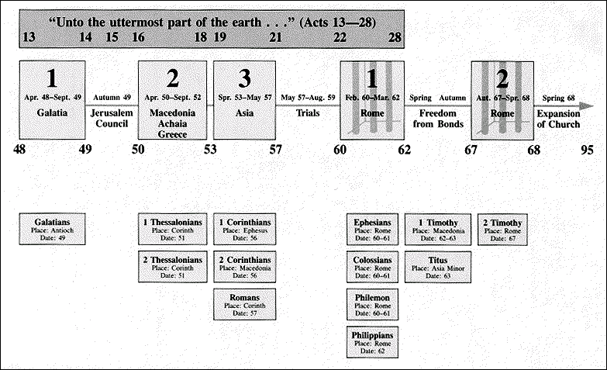Nicopolis (T, 3:12)

The Imprisonment of Paul (II, 1:16-17; 2:9; 4:6-8, 16-18)

Released from Prison (62 AD)

Writes 1 Timothy (62-63 AD)

Writes Titus (63 AD)

Writes 2 Timothy (66-67 AD)

Paul Martyred (67 AD)

The Proposed Conclusions

Paul was released from his first Roman imprisonment (Phil 1:18-19, 24-26; 2:24; Phlm 22) and these 3 letters were written afterward [Knight; Mounce; Fee; Towner (?); MacArthur; EBC (?); BKC]

The 3 letters were written during the time recorded in the book of Acts,possibly during a break in Paul’s ministry in Ephesus on the third missionary journey (1 Tim & Tit) and his Roman imprisonment (2 Tim) [Towner (?); EBC (?)]

The 3 letters are pseudepigraphical and were written at the end of the first century or the beginning of the second century

Major Themes [CCC, 659-4]

The False Teachers (I, 1:3-11, 18-20; 4:1-10; 6:3-10; II, 2:16-3:9; 4:3-4; T, 1:10-16; 3:9-11) {Jewish Elements: “myths” (I, 1:4; 4:7; II, 4:4; T, 1:14); “genealogies” (I, 1:4; T, 3:9); “teachers of the Law” (I, 1:7); “those of the circumcision” (T, 1:10)}

Their Ungodly Character

Their False Teaching

Their Divisive Instruction

Their Destructive Consequences

Their Necessary Confrontation

The True Teaching [DPL, 954-5]

“The faith” (I, 1:19; 3:9; 4:1, 6; 5:8; 6:10, 12; II, 3:8; 4:7; T, 1:13)

Sound Teaching (I, 1:10; 6:3; II, 1:13; 4:3; T, 1:9; 2:1, 8)

“The truth” (I, 2:4; 4:3; II, 2:18, 25; 3:7; T, 1:1)

“A trustworthy statement” (I, 1:15; 3:1; 4:9; II, 2:11; T, 3:8)

“These things” (I, 3:14; 4:6, 11; 5:7; 6:2; II, 2:14; T, 2:1, 15)

Church Leadership (I, 3:1-13; T, 1:5-9)

Elders

Deacons

Church Order (I, 2:1-15; 3:14-15; 4:13; 5:3-22; T, 2:1-10) [DPL, 131-7]

The Role of the Church

The Relationships within the Church

Christian Behavior [DPL, 906-16]

Faith (I, 1:4, 19; 4:12; II, 1:5; 2:22; 3:10)

Faithful(ness) (I, 1:12; 3:11; 4:3, 10, 12; 5:16; 6:2; II, 2:2)

Godliness (I, 3:16; 4:7-8; 6:3, 5-6; T, 1:1)

Character Qualities (I, 3:2-12; 4:12; T, 1:6-9; 2:7-8)

The Salvation of God

Savior [DPL, 867-9]

The Father (I, 1:1; 2:3; 4:10; T, 1:3; 2:10; 3:4)

Christ Jesus (II, 1:10; T, 1:4; 2:13; 3:6)

Save, Salvation (I, 1:15; 2:4, 15; 4:16; II, 1:9; 2:10; 3:15; 4:18; T, 3:5)

I Timothy [MSB, 1826-8; ESVSB, 2321-4; HSB, 2081-4; CMINT, 571-77; RFW, 168-70]

Date: c. AD 63

Purpose: Paul exhorted and instructed Timothy (and the Ephesian church) to stop the influence of false teachers and restore order in the Church [see CCC, 646-7]

The Literary Structure: see outline [CCC, 650-1, 652-3]

The Prologue (1:1-20)

The Salutation (1:1-2)

Paul's Charge to Timothy: Withstand False Teaching and Further the Gospel (1:3-20)

The Content of the Charge: Preserve the Purity of the Gospel (1:3-11)
- The Error of False Teachers (vv. 3-4)

- The Goal of False Teachers (vv. 5-7a)

- The Results of False Teachers (vv. 7b-11)

Paul's Conversion and Commission as an Example of the Truth of the Gospel (1:12-17)
- The Source of God’s Grace (v. 12)

- The Need for God’s Grace (v. 13a)

- The Abundance of God’s Grace (vv. 13b-14)

- The Incredulity of God’s Grace (vv. 15-16)

- The Glory of God’s Grace (v. 17)

The Renewed Charge: The Trust Given to Timothy (1:18-20)
- The Motivation for Engaging in Spiritual Conflict (v. 18a)

- The Mandate for Engaging in Spiritual Conflict (v. 18b)

- The Method for Engaging in Spiritual Conflict (v. 19a)

- The Momentousness of Engaging in Spiritual Conflict (vv. 19b-20)

